How 5G Paves the Way for the Driverless Car

By letting auto makers transmit larger amounts of data, the technology will make it easier for cars to talk to one another
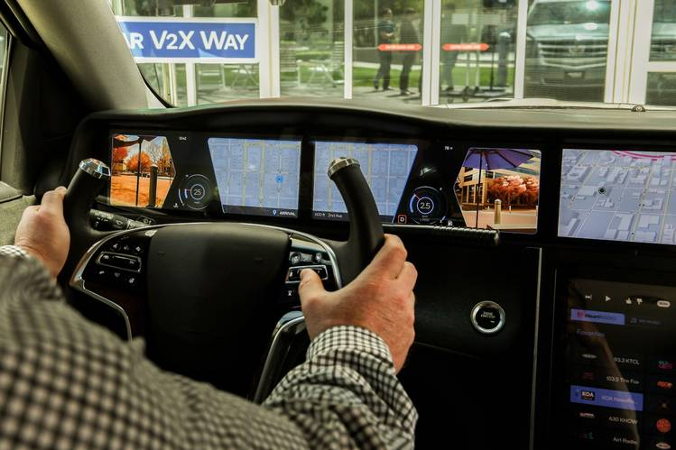
The dashboard in a Qualcomm demo gives a glimpse of how much information can be piped into a 5G vehicle.
By Chester Dawson Sept. 12, 2018 12:34 p.m. ET
Auto makers are looking to the fifth generation of internet connectivity to power new streaming services in the car and accelerate the industry’s shift to driverless vehicles.
While the new broadband technology is still several years away from hitting the road, the deployment of 5G connections in cars will allow auto makers to transmit larger amounts of data with greater reliability and at speeds far faster than the current-generation cellular service, known as 4G.
The shift could pave the way for a range of new features, such as vehicles that can “talk” directly with each other on the road—a catalyst for more widespread deployment of autonomous vehicles—and entertainment options that make the car’s back seat feel more like a home theater.
Auto makers also are hoping broader bandwidths will help generate reams of data that can be used to refine maps, report on roadway conditions and provide instant feedback on a car’s performance.
With 5G, “we’re able to do much more targeted and sophisticated engineering,” says Don Butler, head of Ford Motor Co.’s connected vehicle program.
“As the world itself becomes more connected, it only makes sense that vehicles need to be part of that ecosystem,” he adds.
Car companies are looking to piggyback on the telecom industry’s ambitious plans to start rolling out residential 5G broadband services in limited markets, such as New York, Los Angeles, Dallas, Houston and other test markets later this year, followed by mobile 5G early next year. AT&T Inc., T-Mobile US Inc., Verizon Communications Inc. and other cellular providers are now spending billions to replace 4G cell towers and roadside infrastructure with the faster connections.

Ready off the lot
The arrival of 5G comes as more cars are rolling off dealer lots with built-in modems that allow them to link to the internet through a cellular connection. Auto makers are looking toleverage those connections into potential moneymaking ventures by using the data they collect from vehicles to build new apps, services and in-car advertisements.
A handful of brands already install modems as standard equipment, and industry analysts say most new cars sold in the U.S. will be shipped with internet connections by early next decade.
Global shipments of cars with factory-installed modems are forecast to grow to more than 35 million vehicles by 2022 from 10 million last year, according to Counterpoint Research.
Today most internet-connected cars with modems use 4G broadband technology, which has enabled Wi-Fi hot spots and streaming services, allowing passengers to surf the Web and listen to their favorite music on demand. The transition to 5G technology isn’t likely to happen until the 2021 vehicle model year, industry analysts say, because telecom companies are only starting to invest in 5G transmission infrastructure and automotive-grade chip sets won’t be ready until then.
Even then, 5G may still be limited to higher-end luxury models because installing the new hardware is expensive, limiting its appeal for mass-market vehicles.
The launch of 5G service will also take longer to reach rural areas, as network providers focus first on big cities with denser populations.
Still, auto makers think this next wave of cellular connectivity will help improve safety by allowing cars to communicate directly with one another and crowdsource information on roadway hazards and weather conditions.
The industry also sees promise for developing more interactive entertainment options for passengers sitting in the rear, such as videoconferencing and multiplayer games, or augmented reality that allows cars to offer annotated, self-directed tours. The 5G services will allow for bigger and higher-resolution displays to stream video with little interruption, according to auto industry officials.
“We’re seeing requests for huge, high-resolution displays—up to 10 in a car” with 5G connectivity, says Andrew Poliak, vice president of product planning and innovation at Panasonic Corp.’s auto division. “Try streaming over even one display in a 4G” car and it’s a challenge due to lower data-transmission speeds, he says.
Such features will become more relevant as auto makers advance autonomous-driving technologies that free the driver to perform other tasks while in the car.
The technology will also allow self-driving cars to share data and information among themselves, helping to deploy them at scale, says Glen De Vos, chief technology officer at automotive software supplier Aptiv PLC. “More data coming off the vehicle means more interesting analytics,” Mr. De Vos says. “You’d kill your data plan with that today on 4G.”

No killer app
Some skeptics, however, say 5G’s applicability in cars is overrated and isn’t necessary for making self-driving cars a market reality. That is because driverless cars will need to be able to operate independently from an internet connection in the event one isn’t available.
“The killer app for 5G in cars is still missing. It may come in time, but it’s not evident yet,” says Lars Reger, chief technology officer for NXP Semiconductors NV’s auto unit.
General Motors Co. and Toyota Motor Corp. are backing more limited, Wi-Fi-based connections for cars that talk to one another and to infrastructure like stoplights, arguing that more mature technology is commercially ready now.
Other car makers, such as Ford and BMW AG, are pushing for cellular-based connectivity to become the industry standard for cars to communicate with one another. That rift has widened even as auto makers seek a common format to develop advanced safety features that can prevent accidents.
Auto suppliers are hopeful the larger data pipeline from 5G will also allow them to develop more sophisticated equipment, such as virtual displays on the windshield that show real-time traffic information or weather hazards or details on nearby retailers like store hours.
But the data flow needs to be presented in a way to avoid overwhelming or distracting drivers, says Phil Ventimiglia, a multimedia engineering manager at global auto supplier Robert Bosch GmbH’s U.S. operations.
Says Mr. Ventimiglia, “We don’t want people playing ‘Angry Birds’ while driving down the road—unless they’re in autonomous driving mode.”
Mr. Dawson is a reporter in The Wall Street Journal’s Detroit bureau. He can be reached atchester.dawson@wsj.com.
Appeared in the September 13, 2018, print edition as '5G Can Pave the Way for Driverless Cars.'

